

UNIVERSITY OF BAHRAIN

COLLEGE OF SCIENCE

DEPARTMENT OF CHEMISTRY

Determination of Antioxidant activity of some plants and investigation of their use as a chicken preservative

<Font Style Times New Roman – Bold>

A PROJECT REPORT

in partial fulfillment for the award of the degree of

B.SC in Chemistry

BONAFIDE CERTIFICATE

Abstract:
Antioxidants play an important role in food preservation by inhibiting oxidation processes and contributing to health promotion rendered by many dietary supplements, nutraceuticals and functional food ingredients. In this study six different types of plant material were evaluated for %antioxidant activity. Air-dried samples were extracted with water, the extracts were investigated for their antioxidant activity using (DPPH) radical scavenging activity. Mint extract was found to have the highest % of DPPH (79.4%) scavenging activity. The selected plants were tested for their ability to prevent of chicken spoilage. Chicken samples were mixed with plant extracts and left for a certain time at room temperature. The degree of oxidation was then determined by measuring the amount of VOCs produced. GC-MS was used to identify the VOC which was found to be DMA gas. GC-FID was used to study the rate of spoilage of chicken using antioxidants and without antioxidant. It was found that the presence of antioxidant extract can reduce the rate of spoilage. Mint extract has the highest effect on reducing the oxidation process of the chicken samples.

Table of Content
Cover page ……………………………………………………………………… 1
Bonafide certificate ……………………………………………………………... 2
Declaration ……………………………………………………………………… 3
Dedication ………………………………………………………………………. 4
Abstract …………………………………………………………………………. 5
Acknowledgment ……………………………………………………………….. 6
Table of content ………………………………………………………………… 7
List of tables ……………………………………………………………………. 10
List of figures …………………………………………………………………... 11
Abbreviations …………………………………………………………………... 12
Instrumentation ………………………………………………………………… 12

Chapter 1: Introduction ……………………………………………. 13
1.1 Spoilage of food …………………………………………………………….. 14
12. Chicken spoilage mechanism ……………………………………………….. 16
1.2.1 Microbial spoilage ……………………………………………………... 16
1.2.2 Lipid Oxidation ………………………………………………………... 17
1.2.3 Autolytic spoilage ……………………………………………………... 17
1.3 Determination of Volatile organic compound (VOC) by GC ………………. 18
1.4 Chicken preservative technique …………………………………………….. 18
1.4.1 Low temperature methods ……………………………………………... 18
1.4.2 Controlling water activity ……………………………………………… 19
1.4.3 Chemical methods …………………………………………………… 19
1.4.3.1 Sodium chloride NaCl ………………………………………….. 19
1.4.3.2 Sugars …………………………………………………………... 19
1.4.3.3 Nitrites ………………………………………………………….. 20
1.4.3.4 Lactic Acid ……………………………………………………... 20
1.4.3.5 Phenolic antioxidant ……………………………………………. 20
1.4.3.6 Phosphates ……………………………………………………… 20
1.4.3.7 Ascorbic acid …………………………………………………… 21
1.4.3.8 Benzoic acid ……………………………………………………. 21
1.5 Antioxidants ………………………………………………………………. 21

Chapter 2: Experimental …………………………………………… 23
2.1 Material …………………………………………………………………… 24
2.2 Methods …………………………………………………………………... 24
2.2.1 Antioxidant activity test by using DPPH …………………………... 24
2.2.1.1 Aqueous extraction …………………………………………. 24
2.2.1.2 Determination of antioxidant activity ……………………… 25
2.2.2 Preparation of chicken sample …………………………………….. 26
2.2.3 Identification of VOC by GC-MS …………………………………. 26
2.2.4 Determination of VOC by GC-FID ………………………………... 26

Chapter 3: Discussion ………………………………………………. 27
3.1 Determination of antioxidant activity …………………………………… 28
3.2 Identification of VOC by GC-MS ………………………………………. 30
3.3 Determination of VOC by GC-FID ……………………………………... 31
3.3.1 Basil extract as a preservative for chicken ……………………… 32
3.3.2 Cumin extract as a preservative for chicken .…………………… 33
3.3.3 Dill extract as a preservative for chicken …………………..…… 34
3.3.4 Mint extract as a preservative for chicken ……………………… 35
3.3.5 Black pepper extract as a preservative for chicken ….…..……… 36
3.3.6 White pepper extract as a preservative for chicken ……...……… 37
3.4 Comparison between the effect of plants extract on chicken preservative … 38

Chapter 4: Conclusion and future work …………………………... 39
4.1 Conclusion ……………………………………………………. 40
4.2 future work ……………………………………………………. 40

References …………………………………………………….. 41
Appendix ……………………………………………………… 44

List of tables:
Table (1): The absorbance and % antioxidant activity with aqueous extraction using DPPH.
Table (2): Area under the peak of DMA produced when basil extraction used as preservative.
Table (3): Area under the peak of DMA produced when Cumin extraction used as preservative.
Table (4): Area under the peak of DMA produced when Dill extraction used as preservative.
Table (5): Area under the peak of DMA produced when Mint extraction used as preservative.
Table (6): Area under the peak of DMA produced when Black pepper extraction used as preservative.
Table (7): Area under the peak of DMA produced when white pepper extraction used as preservative.
Table (8): Comparison the % antioxidant activity and the effect of antioxidant on spoilage rate

List of figures:
Figure (1): Store of plant material in glass bottle.
Figure (2): Fresh boneless chicken breast sample.
Figure (3): Aqueous extraction of plant material.
Figure (4): Using steam bath for aqueous extraction.
Figure (5): Mixing plant extract with DPPH solution.
Figure (6): Measuring the absorbance of plant extraction.
Figure (7): DPPH absorption at 517nm
Figure (8): Peak and fragmentation of DMA amine in mass spectrum.
Figure (9): Area under the peak when the preservative used compare to area when no preservative added.
Figure (10): Relative area of DMA produced when Basil extract used as preservative versus the time of DMA measurement.
Figure (11): Relative area of DMA produced when Cumin extract used as preservative versus the time of DMA measurement.
Figure (12): Relative area of DMA produced when Dill extract used as preservative versus the time of DMA measurement.
Figure (13): Relative area of DMA produced when Mint extract used as preservative versus the time of DMA measurement.
Figure (14): Relative area of DMA produced when Black pepper extract used as preservative versus the time of DMA measurement.
Figure (15): Relative area of DMA produced when White pepper extract used as preservative versus the time of DMA measurement.
Figure (16): Comparison between the effect of antioxidant activity of plant extract.
Figure (17): Correlation factor between % AO activity and % effect of antioxidant on spoilage rate.

Abbreviation:
DPPH: 2,2-diphenyl-1-picrylhydrazyl
VOC: Volatile Organic compounds
TMA: trimethylamine
DMA: dimethylamine
AO%: antioxidant activity
UV/VIS: ultraviolet/visible
GC-MS: gas chromatography – mass spectrometry
GC-FID: gas chromatography – flame ionization detector

Instrumentation:
- UV/VIS – Spectrophotometer (PerkinElmer, Lambda XLS, spectrophotometer)
- Gas chromatograph (PerkinElmer clarus 600 C) linked to mass spectrometer (PerkinElmer 600 clarus C, TurboMass, version 5.4.2)
- Gas chromatograph (PerkinElmer clarus 500 C)

Chapter 1
Introduction

1.1 Spoilage of food
Meat is a highly perishable nutritious protein. It is a rich food that has a short shelf life if preservation methods are not used. For many people around the world, it is the first-choice source of animal protein. Meat consumption continues to grow worldwide. Although meat consumption is increasing worldwide, every year a significant portion of meat and meat products is spoiled. Microbial spoilage is responsible for the significant portion of this loss (1).
The transformation of animals into meat involves several activities: (a) the handling and loading of animals on the farm, (b) the transport of animals to slaughterhouses, (c) the removal and holding of animals and (d) the slaughter of animals. In any of these operations, poor operational techniques and facilities lead to unnecessary suffering and injury to animals, which can lead to reduced meat quality and meat. Preventing contamination after slaughter, cutting and processing of meat is therefore essential. Hygienic slaughter and clean handling of the carcass can extend the storage time (8).
Slaughtering involves different technical operations: (a) stunning, (b) bleeding (c) skinning (d) evisceration and (e) division of the carcass. Insufficiency at one stage will have a rigorous negative impact on the product and/or process at the next stage. In addition to the temperature of hygiene and storage, the meat acidity and muscle tissue structure also affect the meat spoilage rate. The liver spoils faster than the firm muscle tissue of beef, for example. After a couple of hours of animal slaughter, the muscles become firm and rigid, a condition called rigor mortis. The rigorous mortis process depends on the stress on animals during the slaughter process. The quality of raw meat is reported to be severely affected by stress during slaughter and slaughter methods (1).
Food spoilage may be defined as a process or change which renders a product undesirable or unacceptable for consumption. This complex ecological phenomenon is the outcome of the biochemical activity of microbial chemical processes which will eventually dominate (2).

The main reason for food spoilage is microbiological, chemical, and physical change that occur to the food and make it undesirable to consume (3).
- Microbiological food spoilage:
Result when microorganisms growing on the food which will produce some enzyme that leads to unacceptable side product in the food.
- Chemical food spoilage:
Result from chemical reaction between components in the food with air or with each other.
- Physical food spoilage:
Result from drying the humid food or humidify the dried food.
Food spoilage leads to economic loss, according to USDA economic research that is done in 2015, approximately 96 pounds of food were lost to human use as follow, fresh fruit & vegetable (19.6%), fluid milk (18.1%), grain product (15.2%) sweeteners (12.4%) meat and meat product (34.7%) (3).
Food spoilage due to chemical oxidation is considered as one of the main problem to our society, usually when food or drink is exposed to oxygen, it will cause a series of chemical reactions including proteins, pigment, fatty acids, and lipids that will produce other unacceptable properties such as toxicity, taste, smell, and color (3).
Many of these reactions take place through free radical reaction mechanism and also include a series of chemical reactions (4).
To prevent the occurrence of food spoilage, the safety (removing or eliminating the causes of diseases in food) was studied separately, governments of most countries have tended to strengthen this concept. However, from a microbiological-ecological point of view the two areas cannot be distinguished. In spite of considerable efforts, microbiological safety assurance seems as remote as ever, even in advanced countries. Death, suffering, economic losses, and civil claims on behalf of victims of foodborne diseases are matched by the economic losses caused by food spoilage (3).

12. Chicken spoilage mechanism
The constituents of meat include fat, protein, minerals, carbohydrates, and water. The meat degrades due to the presence of digestive enzymes, microbial spoilage and fat oxidation. Meat spoilage processes occur as a result of lipid oxidation, protein degradation and the loss of other important molecule, so when proteins and lipids breakdown new compounds that change the flavor, odor, juiciness and texture of meat will be produced (5).
The spoilage process involves three main mechanisms for meat after slaughtering and during processing and storage:
1. Microbial spoilage.
2. Lipid oxidation.
3. Autolysis enzymatic spoilage.

1.2.1 Microbial spoilage:
Meat and meat products supply very good environment for the growth of many types of micro flora that could be pathogen such as (Molds, bacteria and yeast). The major causes of the microorganisms are the skin of the animal and intestinal tract. The concept of micro flora in meat depends on several factors: (1) practice before slaughter (2) age of slaughtered animal (3) treatment during slaughtering (4) control of the temperature during slaughtering, distribution and processing (5) preservation procedure (6) packing of meat method (7) storage and handling by people (6).
The main type of bacteria that exists in meat before spoilage is Staphylococcus, Bacillus, Campylobacter, Clostridium, Listeria and Salmonella. The mold found in meat contain Cladosporium, geotrichum, penicillium, and Mucor, however yeast contain candida species and Cryptococcus species. The type of Microbes found in meat and meat products can be affected by the storage condition. A pH between 5.5 and 7.0 is suitable for the growth of bacteria in meat. Within this pH microbial growth can be detect by the following methods: structural components degradation, off odor, appearance change and slime formation (7).

1.2.2 Lipid Oxidation:
The natural process that affects to fatty acids and lead to oxidative spoilage of meat and off-flavors development is called " Autoxidation of lipid “. After slaughtering the animals, blood circulation stops and metabolic processes are blocked that will leads to the oxidation of tissues in fatty acids. Various factors can affect the oxidation of lipids in meat and they are: fatty acid composition, the level of the antioxidant vitamin E and prooxidants such as the free iron present in muscles. The most sensitive fatty acid to lipid oxidation is polyunsaturated fatty acid. Auto oxidation of highly unsaturated fatty acids of membrane phospholipid lead to produces hydrogen peroxides which are capable of oxidation or decomposition. Their brakeage produce carbonyl compounds such as ketones and aldehydes. These secondary products can be the reason for loss of nutritive value and loss of color because of its severe effect on proteins, vitamin, lipid, pigment and carbohydrate (9).

In meat, two type of lipid hydrolysis occur, enzymatically and non-enzymatically, the enzymatic hydrolysis of fats is described as fat spoilage or lipolysis. Fat spoilage is controlled by specific enzymes like lipases, phospholipase and esterase. lipolytic enzyme can be self-growth of food product (milk) or derived from psychotropics bacteria, lipases enzyme is existing in tissue, blood and skin of animal. While lipolysis occurs, lipases dissociate the glycerides formation of free fatty acids responsible for popular off-flavor often lead to rancidity. The major enzymes present in meat lipid hydrolysis are phospholipase A1 and A2. Heme protein such as cytochrome, myoglobin, and hemoglobin due to non-enzymatic hydrolysis which are very sensitive to production of hydrogen peroxide and oxidation process (10).

1.2.3 Autolytic spoilage:
The major causes of meat spoilage is a process called enzymatic action and it is a natural process that occurs after the slaughtering of the animal in the muscle cell. The enzymes can react with other organic compounds and act as a catalyst in the reaction that finally will leads to meat self-spoilage. During the Autolysis process the large complex molecule (protein, carbohydrate and fats) breaks down into smaller parts that leads meat to be soft and change its color gradually to green. These processes involve proteolysis and fat hydrolysis because they are very important for microbial decomposition. Souring is a special name for excessive autolysis. Anatomy after death of polypeptides is caused by tissue proteases and it can control the change of the texture of meat and its flavor (11).

The enzymes calpain, amino peptidases and cathepsins play an important role in the autolysis of meat by digestion of the z- line proteins of the myofibril. The proteolytic tenderization of the meat process can occur through these enzymes. Proteolytic enzymes prefer to work at low temperature (5º C) this will result in the spoilage of meat because of biogenic amines production and growth of microbes (12).

1.3 Determination of Volatile organic compound (VOC) by GC
The determination and separation of VOCs that are produced by the meat after spoilage can be detected and quantified by gas chromatography-mass spectrometry (GC-MS) (13).
The volatile organic compound includes TMA (Trimethylamine) produced by bacteria and DMA (Dimethylamine) produce by autolytic enzymes during storage (14). Recently there is a new detector called barrier ionization detector (BID), this detector can detect all volatile compound except helium and neon, also this detector is more sensitive than flame ionization detector (FID) and mass spectrometry detector (MS) (15).

1.4 Chicken preservative technique
The importance of preservation in meat is to save it from spoilage during transport for long distances. The purpose of the preservation of meat is to reduce the oxidation and enzymatic spoilage and to prevent microbial spoilage from occurring. Old methods of preserving meat such as canning, smoking, brining and drying have been changed to new methods such as bio preservative, nonthermal, and chemical techniques (16). For now, the meat preservation methods are divided into three techniques: use of chemical or bio preservatives, controlling water activity, and controlling the temperature. All of these techniques are used to prevent or reduce the spoilage process from occurring (17).

1.4.1 Low temperature methods:
The main purpose of cooling methods is to reduce the spoilage rate because the low temperature conditions can prevent the microbial growth. There are three methods to store meat at low temperature: chilling, freezing and super chilling, all of them are good in preventing the growth of bacteria in meat and also can stop the growth of bacteria completely (16).

1.4.2 Controlling water activity:
Microbiological food safety is directly affected by the activity of water (aw). Water activity refers to water that supports the development of microorganisms. It represents the ratio of the food's water vapor pressure to the pure water vapor pressure at the same conditions (18). The activity of water in meat products corresponds to the relative humidity of air in balance with the product. Most fresh meats, fruits and vegetables are categorized as moist foods, have more than 0.85 water activity and require refrigeration or other barriers to control the growth of pathogens. Each microorganism has minimal, optimal and maximum water activity. Microorganisms usually grow best between aw values of 0.980-0.995 and growth stops at aw < 0.900. Yeasts and molds can grow at an altitude of 0.6. However, pathogens are prevented from growing at 0.85 aw the growth of gram - negative bacteria in processed and cured meats (that can tolerate an aw of 0.94-0.97) can be suppressed by water activity reduction. Meat water activity is controlled by drying, cooling, adding chemicals or combining these methods. Sodium chloride and sugar are used to control water activity, as free water binds in its presence, which leads to an osmotic imbalance and inhibits cell growths (19).

1.4.3 Chemical methods:
1.4.3.1 Sodium chloride NaCl:
In growth media or foods, sodium chloride (NaCl) can cause osmotic stress by reducing water activity. Microorganisms that are sensitive to salt such as Pseudomonas species do not grow in meat if water activity is reduced from 0.99 to 0.97 by adding 4% sodium chloride. At this level of water activity, however, salt - tolerant microorganisms such as lactic acid bacteria and yeasts could grow (20).

1.4.3.2 Sugars:
Sugars can bind to humidity and reduce water activity in food. In the processing of dried meat, dextrose, sucrose, brown sugar, corn syrup, lactose, honey, molasses and starches are generally used as a source of sugar or carbohydrates to improve flavor, reduce the harshness of salt and reduce the activity of water. (21)

1.4.3.3 Nitrites:
Potassium nitrate and sodium nitrate are used as meat preservation. Nitrite has the ability to stabilize the rancidity, color, smell and flavor of rad meat. Nitrite salts are active in controlling anaerobic bacteria, lipid oxidation, color, and odor of the meat (22).
Nitrites play an important role in many chemical reactions which can prevent the growth of bacteria in food by : (1) blocking sulfhydryl groups which interferes with the sulfur nutrition of the organism, (2) reacting with alpha-amino groups of the amino acids at low pH levels, (3) reacting with iron-containing compounds which restricts the use of iron by bacteria (4) interfering with membrane permeability which limits the transport across cells. (29)
4
1.4.3.4 Lactic Acid:
Lactic acid has the ability to reduce pH level, interfere with proton transfer across cell membrane and exert feedback inhibition which will show act as an antimicrobial to many pathogens such as clostridium botulinum. Lactate is a lactic acid salt plays an important role in preventing unacceptable microorganism in food by producing a substances such as, hydrogen peroxide and acetic acid (24).

1.4.3.5 Phenolic antioxidant:
The compounds that are synthesized from phenol such as propyl gallates (PG) and butylated hydroxy anisole (BHA) are capable of serving as antioxidants. These compounds which have a wide range are used with the intention to delay, and to prevent the bad effect of the oxidation of lipids by reducing the formation of primary and secondary radicals and by scavenging chain-carrying peroxyl radicals. (9)

1.4.3.6 Phosphates:
Phosphate is one of the old techniques used for the preservation of food. Phosphate as an antioxidant has the ability to prevent the spoilage of meat, sea food and chickens. The role of the phosphate depends on its type. the functions of phosphates involve the following: (1) improvement of the water binding ability with muscles protein by controlling the pH (2) react with muscle fibers to enhance the emulsification process of fat (3) keep the protein-fat-water system stable. (4) act as chelating ligand to delay the spoilage process (5) reduce the oxidation process by the addition of iron to the system. (25)

1.4.3.7 Ascorbic acid:
Ascorbic acid (vitamin C), D-isoascorbate and sodium ascorbate can act as a meat preservative, these compounds have the ability to oxidize reactive compounds in the presence of oxygen with generation of water. Ascorbic acid has been shown to improve antimicrobial activity of nitrites and sulfites, based on a study by the Canadian Food and Drug. Ascorbic acid and its isomers are very effective in preventing the oxidation process of meats, and according to American Food and Drug, ascorbic acid and its isomers are generally recognized as safe (GRAS) (26).

1.4.3.8 Benzoic acid:
Benzoic acid and its derivative sodium benzoate are very effective in meat preservation. The stability of benzoic acid molecule is responsible for its antibacterial activity. The purpose of using benzoic acid is to prevent the growth of fungi and yeast rather than bacteria. At pH between (2.5-5) benzoic acid exist in its undissociated that which can readily crosses the cell membrane. In Canada, benzoic acid is not permitted for unstandardized meat and the limit for benzoic acid is 1000 ppm for marinated or similarly cold-processed packaged meat. while in America the maximum permitted level for benzoic acid and sodium benzoate is 0.1% as Generally Recognized as Safe (GRAS) preservatives. (27)

1.5 Antioxidants
Oxidation processes have the ability to affect the acceptability and quality of meat and meat products. It can affect its texture, taste, nutritional value and color. The main cause of oxidative chain reactions are free radicals that are combined with oxygen, pigment, vitamin, protein and lipid. There are many studies that has been done to synthesize preservatives from natural sources for meat and meat products. Antioxidants are used to maintain sensory attributes and to prevent the occurrence of the oxidation process. Some of these preservative techniques are not safe because it causes bowel, and stomach allergy like an ascorbic acid, phenolic antioxidants, and nitrites. (28)
Preservation of meat with natural antioxidant is a very good idea because it can minimize the use of synthetic additives which are not very safe. The purpose of Mixing and filling the natural antioxidants with meat product is to increase the shelf-life of product with maintaining their nutritional values. Extract and essential oil from plants, spice and pills residues are considered as the common natural antioxidants for the preservation of meat. (29)
The common method for examining the antioxidant activity of substance is the free radical method with DPPH (2,2-diphenyl-1-picryl-hydrazyl-hydrate) based on electron-transfer in a violet solution. The best solvents for DPPH solution is methanol and ethanol in the presence of antioxidant molecules DPPH is reduced to give a free radical electron. DPPH solution is stable at room temp, but it is very sensitive to light. DPPH test for the antioxidant activity is an easy reliable, reproducible and rapid way to check the antioxidant activity for a substance through the measurement of absorbance at 517nm using a spectrophotometer. (30)
A lot of plants involve compound that are considered as antioxidant which have the ability to save the plants from reactive oxygen species (ROS) which is a free radical, such as super oxide, peroxyl and oxygen. Also, enzymes can serve as antioxidants such as glutathione peroxidase, thioredoxin thiols, alphatocopherols that has the ability to inhabit the propagation process for free radical reaction that occur in the cell membrane of human body. (31)
Based on their mechanism, antioxidants are classified into two type: primary and secondary, primary antioxidant can act as a hydrogen donor to stabilize the free radical that leads to preventing the chain reactions of oxidation such as phenolic compounds and tocopherols. Secondary antioxidants prevent the oxidation by controlling the oxidation provider such as single oxygen pro-oxidative enzymes and metal ion. Ascorbic acid is a secondary antioxidant but it can act as a primary antioxidant by the replacement of one hydrogen atom. There are several factors that can affect the antioxidant activity of the substance, temperature, physical state, type of oxidation, chemical structure, the thermodynamics of the reaction, reaction kinetics and the concentration of a substance and the concentration of the system. (32)

In this project, six types of plant materials will be tested for the percent (%) antioxidant activity, the extracted antioxidant will be tested on chicken meat to prove the ability of natural antioxidants on preventing the oxidation process which is the main cause of chicken spoilage. Gas chromatography techniques will be used to determine and separate the volatile organic compound (VOC) produced after the spoilage of the chicken.

Chapter 2
Experimental

2.1 Material
Mint, basil, cumin, white pepper, black pepper, and dill were bought from a local supermarket in duraz, Bahrain. Plant leaves were collected, washed and dried in air for 24 hours. Cumin, black and white pepper were already dry. After drying, the leaves were ground by a high-speed blender. Finally, each type of plant was collected in a labeled glass bottle as shown in Figure (1).
Altanmiah Fresh boneless chicken breasts were bought from local supermarket (AlSater) in Bani-jamrah – Bahrain, Figure (2)
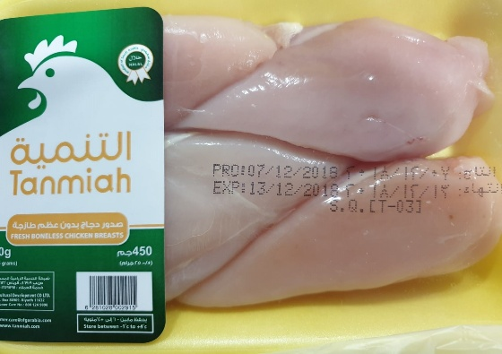
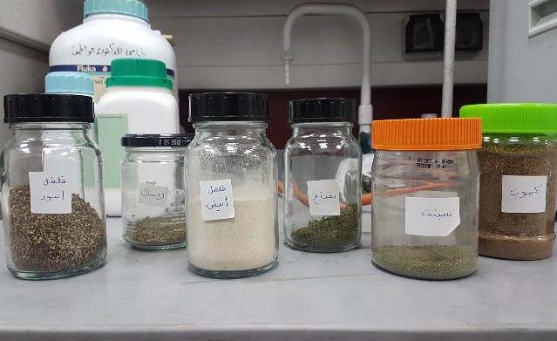
Figure (1): store of plant material in glass bottle
Figure (2): fresh boneless chicken breast sample
2.2 Methods
2.2.1 Antioxidant activity test by using DPPH:
2.2.1.1 Aqueous extraction:
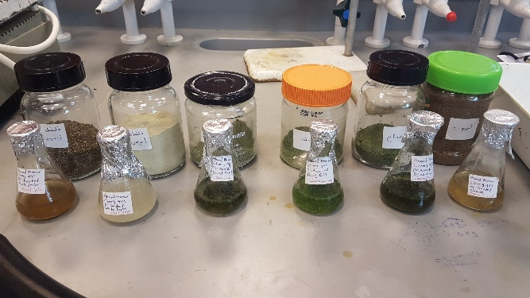
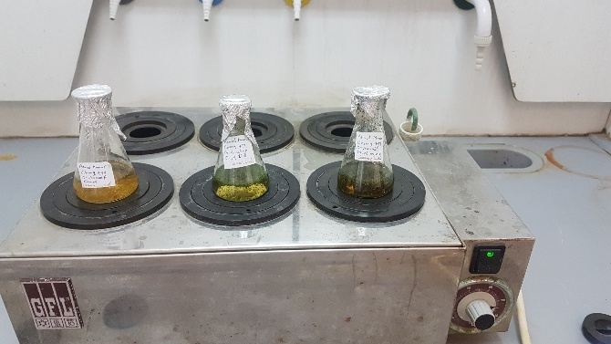
A 0.2g of each plant was weighed in 50-mL labelled conical flask (Figure 3), 25 mL of warm water were added to each flask then placed in a steam bath (Figure 4) at 80º C for two hours. The extracts were then cooled at room temperature to measure the antioxidant activity. (38)
Figure (3): aqueous extraction of plant material
Figure (4): using steam bath for aqueous extraction

2.2.1.2 Determination of antioxidant activity:
DPPH (2,2-diphenyl-1-picrylhydrazyl) solution was prepared in a 100-mL dry volumetric flask by dissolving 4.9 mg of DPPH in a 100 mL of methanol with stirring until all the DPPH dissolves completely (39). The volumetric flask was fully covered by aluminum foil, then the mixture was kept in a dark place for 30 min. In a test tube 2.95 ml of DPPH solution was mixed with 50µL of plant extract by using a micropipette (Figure 5). The mixture was then allowed to stand at room temp in a dark place for 30 min. DPPH solution without any plant extract serves as a blank sample. When DPPH reacts with an antioxidant compound, which can donate hydrogen, it is reduced. The changes in color (from deep violet to light yellow) was measured at 517 nm by using UV-spectrophotometer (PerkinElmer, lambda XLS) (Figure 6) (39). The absorbance relative to the blank was converted to percentage radical scavenging activity using the formula:
The scavenging activity percentage (AO%) = $\frac{abs.blank-abs.sample}{abs.blank}$ x 100
Blank: pure DPPH solution without the extract.
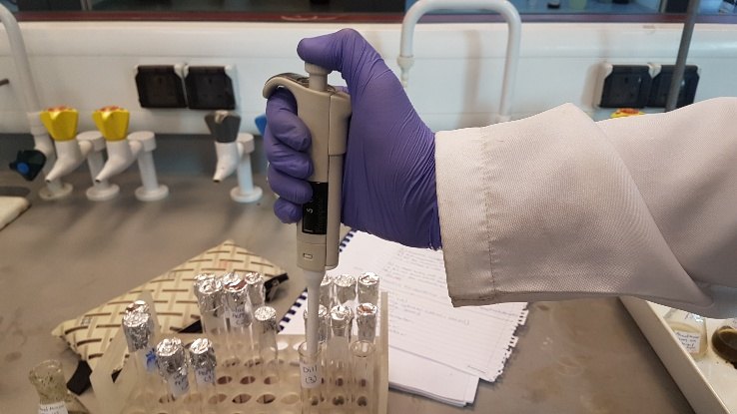

Figure (5): mixing plant extract with DPPH solution
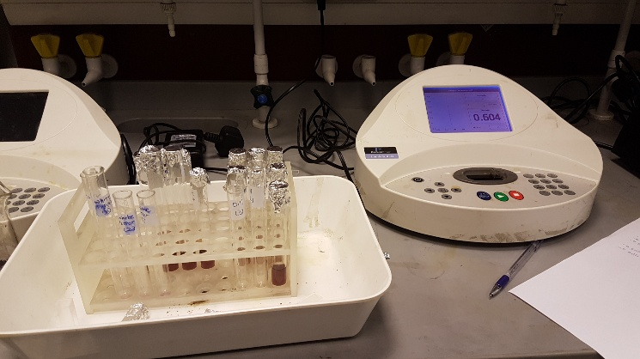

Figure (6): measuring the absorbance of plant extraction

2.2.2 Preparation of chicken sample
Fresh chicken breasts were purchased from a local market and were cut into small pieces. 20g of chicken were placed in each four 100ml round bottom flask. Three samples were mixed with a plant extract and the fourth sample was mixed with the solvent (water) to serve as a control, then all flasks were covered with rubber septum, finally the samples were left at room temperature.

2.2.3 Identification of VOC by GC-MS
For identification of VOCs produced from spoilage of chicken, one sample was analyzed in a gas chromatograph (PerkinElmer, clarus 600 C) linked to mass spectrophotometer (PerkinElmer, clarus 600 C, TurboMass, version 5.4.2). Mass range was set to scan from 10 to 600 m/z, ionization mode was electron impact. Oven temperature was isothermal at 70ºC, helium was used as carrier gas with 0.90 mL/min flow split flow, column dimension (L: 30m, ID:0.25mm, DF:0.25µm). The injection temperature was set at 100º C and injection volume was 100 µL.

2.2.4 Determination of VOC by GC-FID
The identification of the compound that is produced by the spoilage of chicken was accomplished by GC-MS. For the study of the rate of spoilage using different preservatives, the samples were analyzed with a gas chromatograph (PerkinElmer, clarus 500C) with flame ionization detector. Oven temp was isothermal at 100ºC, nitrogen gas was used as a carrier gas with 28.0 psi split flow, column dimension (L:30m, ID:0.25mm, DF:0.25µm). The injection temperature was set at 120ºC, the injection volume was 100 µL.

Chapter 3
Results and Discussion

3.1 Determination of antioxidant activity
Table (1): Absorbance and % antioxidant activity with aqueous extraction using DPPH:
Absorbance of Blank: 1.329
Type of Plant extract | Absorbance Sample (1) | Absorbance Sample (2) | Absorbance Sample (3) | Average  ($\overline{x}$ ± s) | Antioxidant  (AO%)
Mint | 0.276 | 0.267 | 0.280 | 0.274 ± 0.0067 | 79.4 %
Basil | 0.427 | 0.421 | 0.430 | 0.426 ± 0.0046 | 67.9 %
Dill | 0.609 | 0.604 | 0.599 | 0.604 ± 0.0050 | 54.5 %
Cumin | 0.721 | 0.698 | 0.703 | 0.707 ± 0.0121 | 46.8 %
Black pepper | 0.890 | 0.917 | 0.907 | 0.904 ± 0.0136 | 31.9 %
White pepper | 0.940 | 0.965 | 0.951 | 0.952 ± 0.0130 | 28.3 %

Extraction yield and antioxidant activity of the extracts depends on the solvent polarity, extraction time, temperature and physical and chemical properties of the sample. Only one type of solvent was used for extraction which is the water, the extract was done in 25 mL of warm water placed on a steam bath with a temperature of 80º C for two hours.
DPPH solution was prepared by dissolving the solid crystals of DPPH in methanol. The solution was stirred until DPPH dissolved completely for approximately one hour. The volumetric flask used in the preparation of DPPH solution was washed with acetone and dried in air, because DPPH is very sensitive to any impurities and contamination. During preparation, the volumetric flask was wrapped with aluminum foil to avoid any light source that can lead to photodecomposition of DPPH particles because it acts as scavenger to other radicals.
After two hours of heating the plant solution on the steam bath, the solutions were cooled down at room temperature. The plant extracts were filtered and the filtrate was taken into conical flasks, then in the test tube 50 µL of plant extract was mixed with 2.95 mL of DPPH solution, then the mixture was allowed to stand at room temperature for half an hour. This step was also done in a dark environment to avoid any light source that could effect on scavenging of radical’s result.
The advantage of this method is that DPPH was allowed to react with the whole sample in sufficient time whether its weak antioxidant or strong antioxidant. Also, the method can be utilized in aqueous and nonpolar organic solvent. The DPPH method is a fast, easy and reliable method and does not require expensive instruments or glassware or difficult reaction. Change in the color of the DPPH solution from dark purple to yellow-green was noticed when it was disappeared. (33)
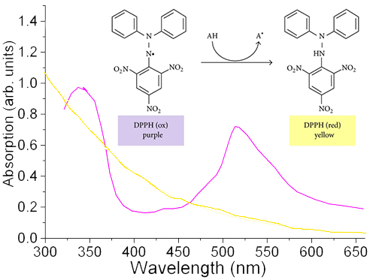
Figure (7): DPPH absorption at 517nm
DPPH free radical can easily accept an electron or hydrogen from an antioxidant molecule to be stable. A solution of DPPH radicals prepared in methanol is converted into DPPH-H molecule in the presence of an antioxidant agent, discoloration of dark purple into yellow is due to the decreasing of the quantity of DPPH radicals in the environment. (34)
As shown in table (1) the highest % of antioxidant activity was found in mint which was equal to 79.4 % followed by Basil 67.9 %. Both extracts show clear discolouration for DPPH solution. The low % of antioxidant activity was found in white pepper 28.3%. This low value might be due to low solubility of the sample. The main disadvantage of aqueous extraction was the low yield in antioxidant with low polarity.

3.2 Identification of VOC by GC-MS
Separation of components in the gas chromatography depends on several factor: vapor pressure, polarity of stationary phase, polarity of the component, flow rate of mobile phase, length and temperature of the column, and the interaction between the sample and the mobile phase. (35)
The combination of gas chromatography and mass spectrometry is called GC-MS. This detector is considered as one of the most powerful detectors for gas chromatography. It measures mass to charge ratio (m/z) of the ions produced from the sample. The flow rate from capillary columns is usually low enough that the column output can be fed directly into the ionization chamber of the mass spectrometer. Most common ion source are electron impact source and chemical ionization. Most common mass analyzed are quadruple and ion-trap analyzer. (36)
Identification of VOCs compound based on their mass spectral data referenced with component published in the literature or the mass data that are stored on the computer library (TurboMass, version 5.4.2).
As shown in figure (8), only one peak with retention time 1.33 min appears. It has the molecular mass of DMA gas which is the gas produced after spoilage of chicken. The figure also shows the fragmentation of dimethylamine DMA in the mass spectrum and lists the compounds that may result to this peak
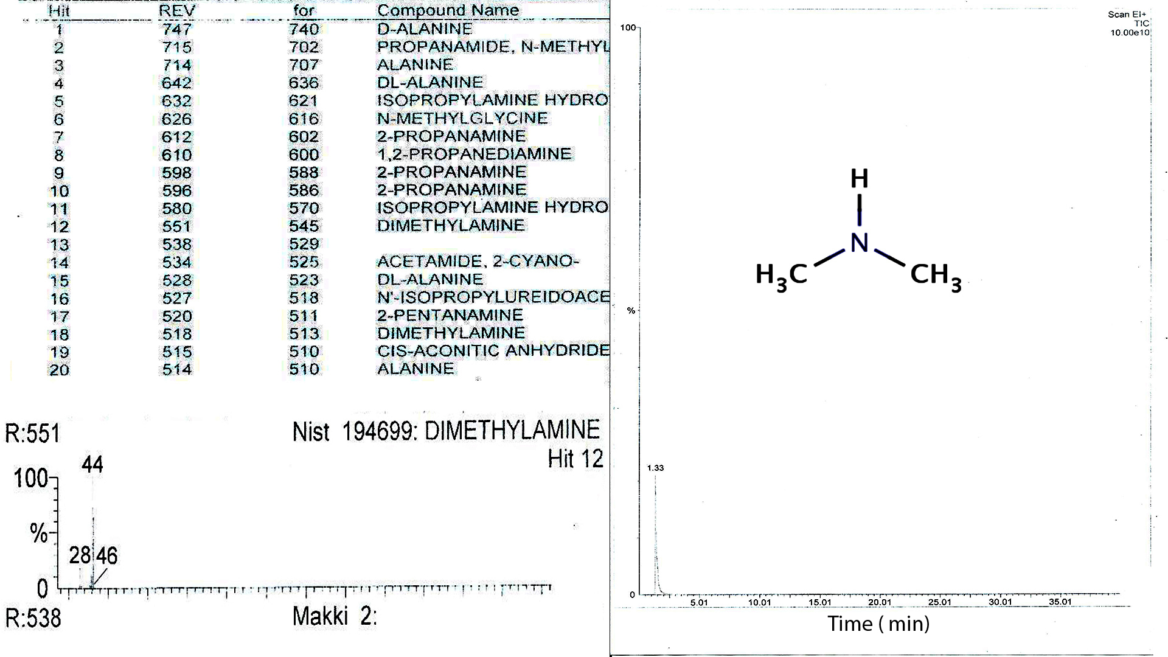
Figure (8): peak and fragmentation of DMA in mass spectrum.
3.3 Determination of VOC by GC-FID
Flame ionization detector is a widely used detector for gas chromatography. Organic compounds are combusted in the H₂/air flame temperature to produce ions and electrons that can conduct electrically through the flame. (36)
Flame ionization detector is sensitive to mass more than the concentration, flame ionization detector is useful for the analysis of the most organic compounds including compound that are contaminated with water and the oxide of nitrogen and sulphur. Flame ionization detector is highly sensitive, low noise and has large linear response range. (36)
Like GC-MS, only one peak appeared in the chromatogram. As shown in the figure (9) the area under the peak when no preservative was added is higher than the area when a preservative used. Also, the chromatogram shows that DMA peak produced when no preservative was added is higher than that obtained for DMA with added preservative. In order to deal with small number, all areas under peaks were divided by the smallest area.
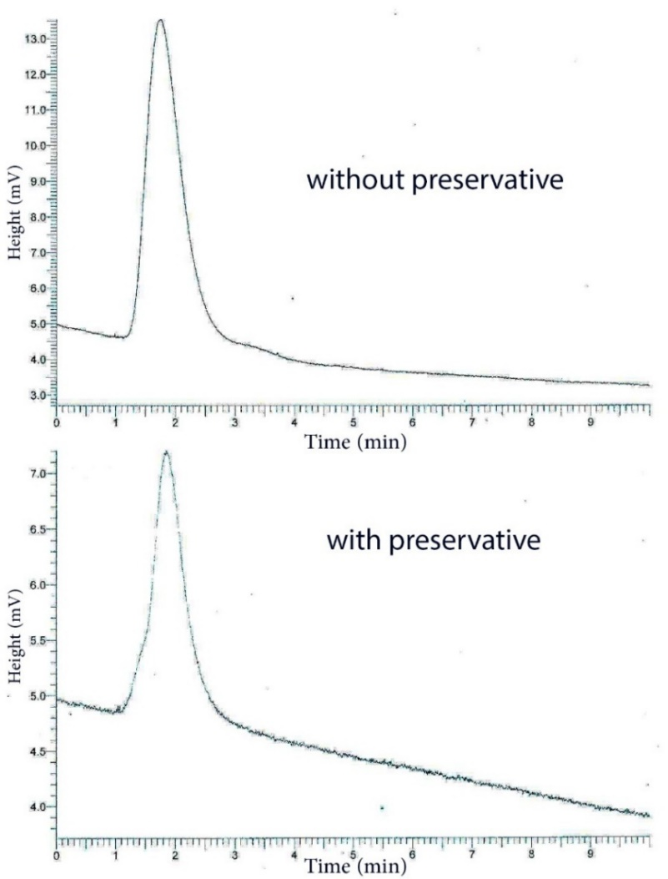
Figure (9): Height of the peak when the preservative used compared to the Height when no preservative added
3.3.1 Basil extract as a preservative for chicken
Table (2): area under the peak of DMA produced when basil extraction used as preservative:
Room temperature: 24ºC
Time of measurement of DMA | Relative area under peak of DMA for the Sample without antioxidant (solvent) | Relative area under peak of DMA for the Sample with antioxidant (Basil)
1 hour | 2.0076 | 1.0708 ± 0.0689
2 hours | 2.4646 | 1.2529 ± 0.0067
3 hours | 2.8095 | 1.4373 ± 0.1587

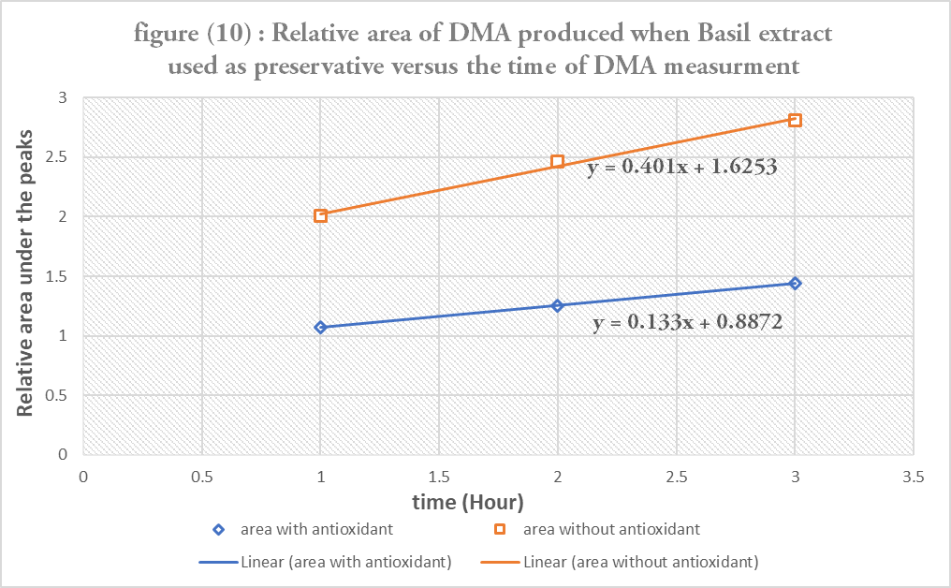
Rate of spoilage without the plant extract = 0.401 s⁻¹
Rate of the spoilage with the plant extract = 0.133 s⁻¹
% The effect of antioxidant on spoilage rate
= $\frac{Rate of spoilage without the plant extract - Rate of the spoilage with the plant extract}{Rate of spoilage without the plant extract }$ x 100
= $\frac{0.401-0.133}{0.401} x 100$ = 66.83%
3.3.2 Cumin extract as a preservative for chicken:
Table (3): area under the peak of DMA produced when Cumin extraction used as preservative:
Room temperature: 25ºC
Time of measurement of DMA | Relative area under peak of DMA for the Sample without antioxidant (solvent) | Relative area under peak of DMA for the Sample with antioxidant (Cumin)
1 hour | 1.4119 | 1.0469 ± 0.0502
2 hours | 2.4057 | 1.3527 ± 0.0235
3 hours | 3.4173 | 1.6302 ± 0.0648
4 hours | 3.9655 | 2.5620 ± 0.0023

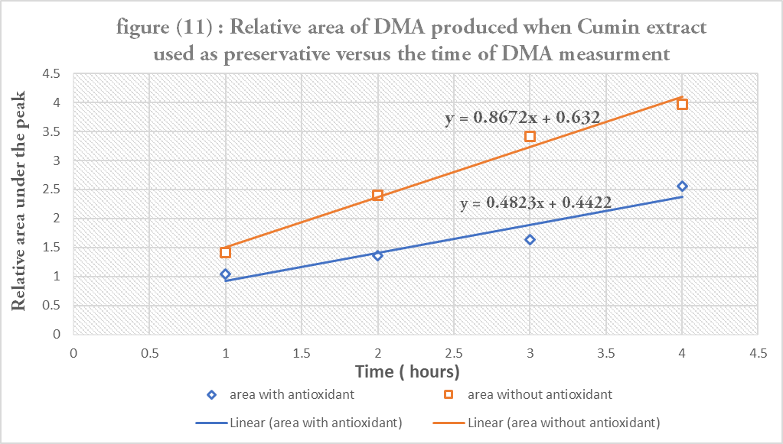
Rate of spoilage without the plant extract = 0.8672 s⁻¹
Rate of the spoilage with the plant extract = 0.4823 s⁻¹
% The effect of antioxidant on spoilage rate
= $\frac{Rate of spoilage without the plant extract - Rate of the spoilage with the plant extract}{Rate of spoilage without the plant extract }$ x 100
= $\frac{0.8672-0.4823}{0.8672} x 100$ = 44.38 %
3.3.3 Dill extract as a preservative for chicken:
Table (4): area under the peak of DMA produced when Dill extraction used as preservative:
Room temperature: 24ºC
Time of measurement of DMA | Relative area under peak of DMA for the Sample without antioxidant (solvent) | Relative area under peak of DMA for the Sample with antioxidant (Dill)
1 hour | 1.7492 | 1.0162 ± 0.0249
2 hours | 2.3972 | 1.6082 ± 0.0592
3 hours | 2.5248 | 1.7542 ± 0.0294
4 hours | 3.0532 | 2.0142 ± 0.0526

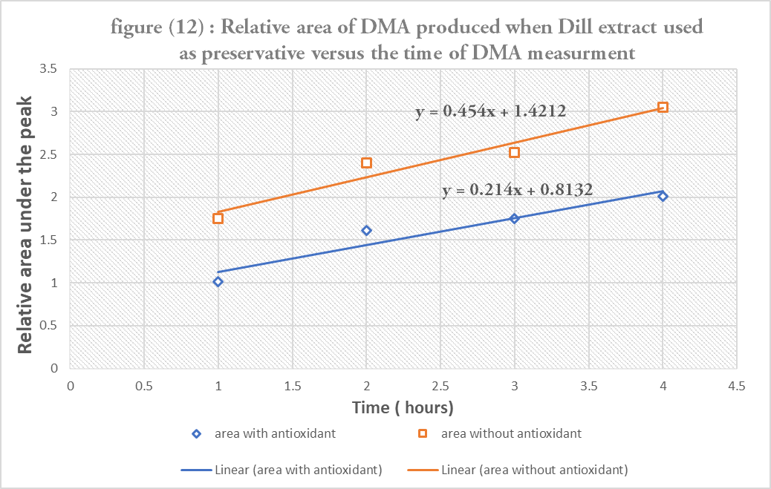
Rate of spoilage without the plant extract = 0.454 s⁻¹
Rate of the spoilage with the plant extract = 0.214 s⁻¹
% The effect of antioxidant on spoilage rate
= $\frac{Rate of spoilage without the plant extract - Rate of the spoilage with the plant extract}{Rate of spoilage without the plant extract }$ x 100
= $\frac{0.454-0.214}{0.454} x 100$ = 52.86 %
3.3.4 Mint extract as a preservative for chicken:
Table (5): area under the peak of DMA produced when Mint extraction used as preservative:
Room temperature: 28ºC
Time of measurement of DMA | Relative area under peak of DMA for the Sample without antioxidant (solvent) | Relative area under peak of DMA for the Sample with antioxidant (Mint)
1 hour | 1.9409 | 1.0235 ± 0.0266
2 hours | 3.0248 | 1.7451 ± 0.0596
3 hours | 4.9455 | 1.9790 ± 0.0033
4 hours | 6.5025 | 2.4548 ± 0.1692

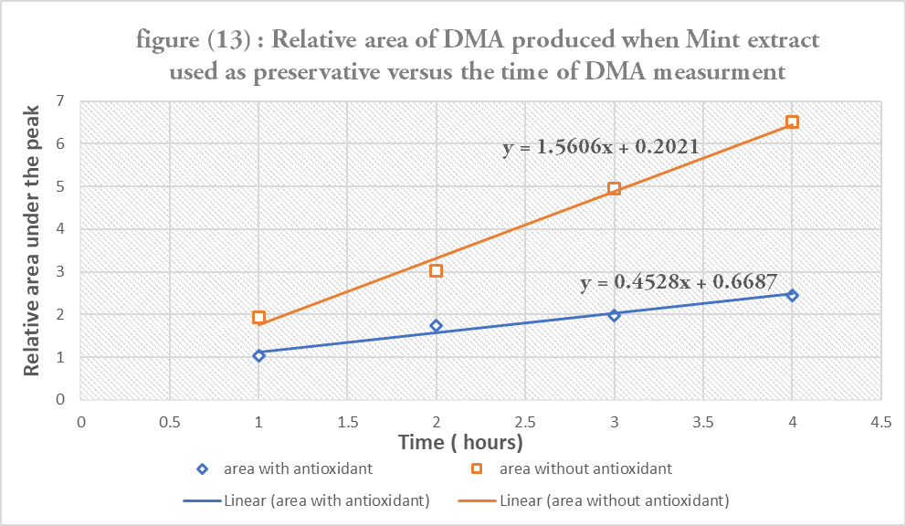
Rate of spoilage without the plant extract = 1.5606 s⁻¹
Rate of the spoilage with the plant extract = 0.4528 s⁻¹
% The effect of antioxidant on spoilage rate
= $\frac{Rate of spoilage without the plant extract - Rate of the spoilage with the plant extract}{Rate of spoilage without the plant extract }$ x 100
= $\frac{1.5606 -0.4528}{1.5606} x 100$ = 70.98 %
3.3.5 Black pepper extract as a preservative for chicken:
Table (6): area under the peak of DMA produced when Black pepper extraction used as preservative:
Room temperature: 26ºC
Time of measurement of DMA | Relative area under peak of DMA for the Sample without antioxidant (solvent) | Relative area under peak of DMA for the Sample with antioxidant (Black pepper)
1 hour | 1.5396 | 1.0773 ± 0.0845
2 hours | 3.0159 | 1.3613 ± 0.0427
3 hours | 4.3832 | 1.7843 ± 0.0925
4 hours | 4.7419 | 3.6706 ± 0.0802

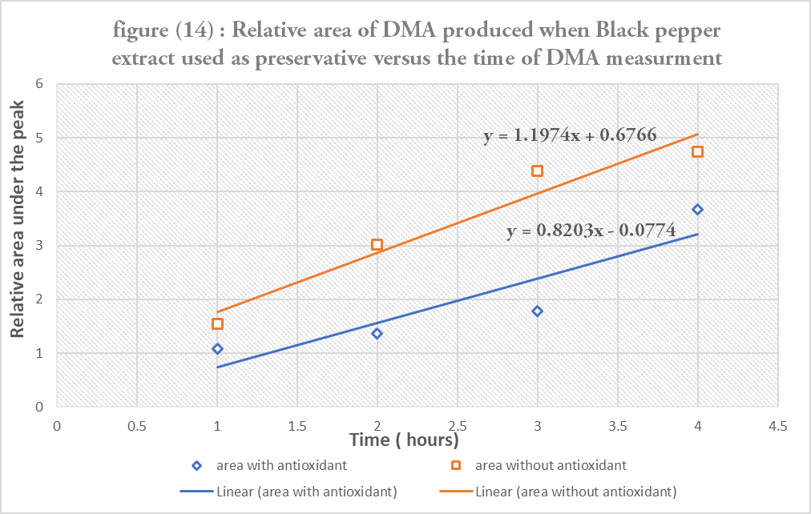
Rate of spoilage without the plant extract = 1.1974 s⁻¹
Rate of the spoilage with the plant extract = 0.8203 s⁻¹
% The effect of antioxidant on spoilage rate
= $\frac{Rate of spoilage without the plant extract - Rate of the spoilage with the plant extract}{Rate of spoilage without the plant extract }$ x 100
= $\frac{1.1974 -0.8203}{1.1974} x 100$ = 31.49 %
3.3.6 White pepper extract as a preservative for chicken:
Table (7): area under the peak of DMA produced when white pepper extraction used as preservative:
Room temperature: 27ºC
Time of measurement of DMA | Relative area under peak of DMA for the Sample without antioxidant (solvent) | Relative area under peak of DMA for the Sample with antioxidant (white pepper)
1 hour | 1.3918 | 1.0065 ± 0.0079
2 hours | 2.4468 | 1.7761 ± 0.1309
3 hours | 3.1489 | 2.6065 ± 0.1081
4 hours | 5.5461 | 3.1348 ± 0.0109

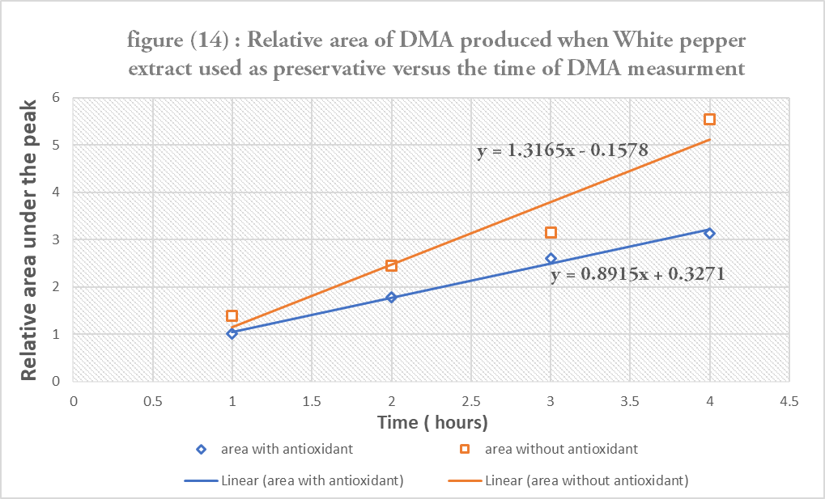
Rate of spoilage without the plant extract = 1.3165 s⁻¹
Rate of the spoilage with the plant extract = 0.8915 s⁻¹
% The effect of antioxidant on spoilage rate
= $\frac{Rate of spoilage without the plant extract - Rate of the spoilage with the plant extract}{Rate of spoilage without the plant extract }$ x 100
= $\frac{1.3165 -0.8915}{1.3165} x 100$ = 32.28 %
3.4 Comparison between the effect of plants extract as preservatives for chicken
Antioxidants can delay, inhabit, or prevent the oxidation of the material by scavenging free radical mechanism, so the addition of antioxidant will lead to increase the storage stability, sensory quality and nutritional value of the meat product. Plant extracts were used in this study due to their high antioxidant capacities as they contain different phenols, anthocyanin’s and ascorbic acid, which can act as radical scavenger. (37)
From the result, mint showed the highest radical scavenging property because it gave the lowest absorbance. Mint also show the highest % antioxidant activity when it is used as chicken preservative (70.98%). Figure (16) shows the % antioxidant activity of all plant extracts with mint having the highest and black pepper having the lowest (31.49%).
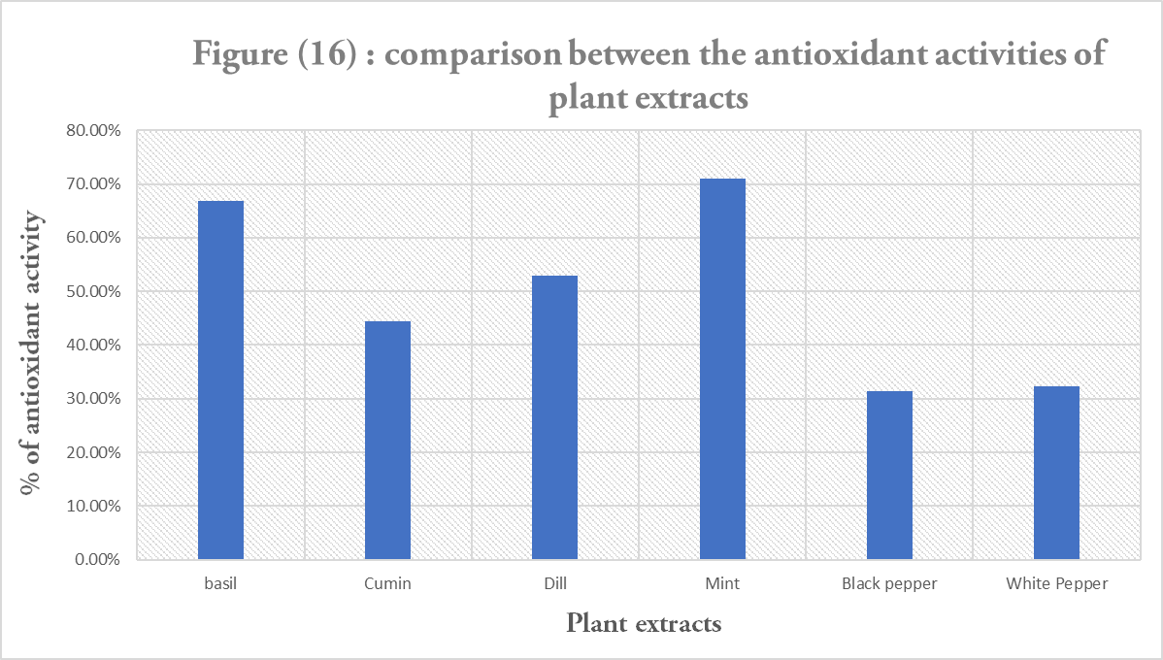

Table (8): Comparison the % antioxidant activity and the effect of antioxidant on spoilage rate:
Type Plant extract | % AO | % Effect of antioxidant on spoilage rate
Mint | 79.4% | 70.9%
Basil | 67.9% | 66.9%
Dill | 54.4% | 52.9%
Cumin | 46.8% | 44.4%
Black pepper | 31.9% | 31.5%
White pepper | 28.3% | 32.3%

As shown in the figure (17), correlation factor between both parameters are very relative and their effect has direct relation with a high correlation factor = 0.9821

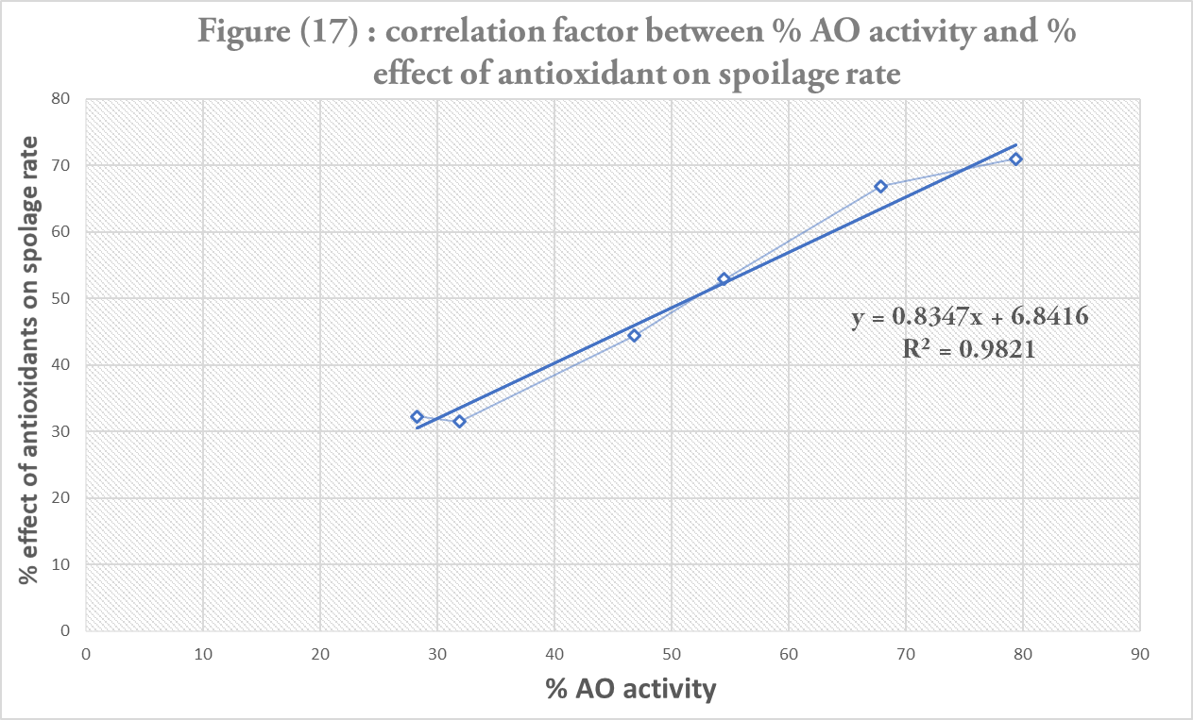

Chapter 4
Conclusion and future work

4.1 Conclusion
Antioxidant activity based on DPPH assay was evaluated for six types of plant. The order of plants %AO from highest to lowest is: Mint > Basil > Dill > Cumin > Black pepper > white pepper. The antioxidant activities of plant were tested on chicken to study their abilities in preventing chicken spoilage as a result of oxidation when exposed to air. Gas chromatography was used to identify VOCs and to study the rate of chicken spoilage when plant extracts were added. The overall result showed a positive correlation between radical scavenging properties of plant extracts and their % antioxidant activities.

4.2 Future work
The following are suggestion for future work: instead of water, organic solvent can be tried for extracting plants to improve % extraction of antioxidant. Also, testing the antioxidant activities of plants on chicken at different storage condition. Finally, testing the antioxidant activity of plant on different food such as fish, meat, and cheese.

References:
(1) Mekonnen Addis, in Food Science and Quality Management, 2015. P.101-114
(2) G-J.E. Nychas, E. Panagou, in Food and Beverage Stability and Shelf Life, 2011
(3) Leonardo Petruzzi, Antonio Bevilacqua, in the Microbiological Quality of Food, 2017
(4) A.I. Smirnov, in Electron Spin Resonance in Food Science, 2017
(5) Heinz, G., and P. Hautzinger, 2007. Meat Processing Technology. For Small-To Medium scale Producers. Food and Agriculture Organization of the United Nations Regional Office for Asia and the Pacific. Retrived on 1st June 2010
(6) Cerveny, J., J.D. Meyer and P.A. Hall, 2009. Microbiological Spoilage of Meat and Poultry Products In: Compendium of The Microbiological Spoilage, Of Foods and Beverages. Food Microbiology and Food Safety, W.H. Sperber and M.P. Doyle (Eds.). Springer Science and Business Media, NY, pp. 69- 868.
(7) Russell, S.M., D.L. Fletcher and N.A. Cox, 1996. Spoilage bacteria of fresh broiler chicken carcasses. Poultry Sci., 75: 2041-2047
(8) FAO, 1990. Manual on simple methods of meat preservation. FAO animal production and health paper 79
(9) Simitzis, P.E. and S.G. Deligeorgis, 2010. Lipid oxidation of meat and use of essential oils as antioxidants in meat products
(10) Kanner, J., 1994. Oxidative processes in meat and meat products: Quality implications. Meat Sci., 36: 169- 189.
(11) Toldra, F. and M. Flores, 2000. The use of muscle enzymes as predictors of pork meat quality. Food Chemistry, 69: 387-395
(12) Kuwahara, K and K. Osako, 2003. Effect of sodium Gluconate on Gel Formation of Japanese Common Squid Muscle. Nippon Suisan Gakkaishi, 69: 637-642
(13) Senter S.D., Arnold J.W., Chew V. (2000): APC values and volatile compounds formed in commercially processed, raw chicken parts during storage at 4 and 13°C and under simulated temperature abuse conditions. Journal of the Science of Food and Agriculture, 80: 1559–1564.
(14) Cosgrove, J.P., D.F. church, and W.A pryor, 1987 the kinetic of antioxidant of poly unsaturated fatty acid. Lipid. 22(5): p.299-304
(15) Franchina FA, Maimone M, Sciarrone D, Purcaro G, Tranchida PQ, Mondello L (2015) Evaluation of a novel helium ionization detector within the context of (low-)flow modulation comprehensive two-dimensional gas chromatography. 1402:102–109
(16) Zhou, G.H., X.L. Xu and Y. Liu, 2010. Preservation technologies for fresh meat-A review. Meat Sci., 86: 119- 128.
(17) Bagamboula, C.F., M. Uyttendaele and J. Debevere, 2004. Inhibitory effect of thyme and basil essential oils, carvacrol, thymol, estragol, linalool and pcymene towards Shigella sonnei and S. flexneri Food Microbiology, 21: 33-42.
(18) Ghaly, A.E., D. Dave, S. Budge and M.S. Brooks, 2010. Fish spoilage mechanisms and preservation techniques: Review. Am. J. Applied Sci., 7: 846- 864
(19) Dillon, V.M., 1996. Yeasts and moulds associated with meat and meat products. In: The microbiology of Meat and Poultry, 1st Edn., Davies, A. and Board, R. (Eds.). Blackie Academic and Professional, London, UK. pp: 85-117
(20) Doyle, E.M., 1999. Use of other preservatives to control listeria in meat. Retrieved on 11th August, 2010,
(21) USDA, 2005. FSRE (Food Safety Regulatory Essentials) Shelf-Stable, Principles of preservation of shelf-stable dried meat products. United State Department of Agriculture. Food Safety and Inspection Service.
(22) Sindelar, J.J. and T.A. Houser, 2009. Alternative curing systems. In: Ingredients in meat products: Properties, functionality and applications. Tarte, R. (Ed.) Springer Science and Business Media, NY, pp: 379-405.
(23) Ray, B. 2004. Fundamental food microbiology (3rd Edition). CRC Press, FL, pp.439-534.
(24) Matamoros, S., M.F. Pilet, F. Gigout, H. Prevost and F. Leroi, 2009. Selection and evaluation of seafoodborne psychrotrophic lactic acid bacteria as inhibitors of pathogenic and spoilage bacteria. Food Microbiology, 26: 638-644
(25) ICLPP, 2006. Meat, Poultry and Seafood: Applications of food phosphates. ICL Performance Products LP, St. Louis, Missouri, USA. http://www.iclperfproductslp. com
(26) Tompkin, R.B., L.N. Christiansen and A.B. Shaparis.2007. The effect of iron on botulinal inhibition inperishable canned cured meat. Int. J. Food Sci. Techn.13: 521 -527.
(27) Krebs, H.A., D. Wiggins and M. Stubbs, 1983. Studies on the mechanism of the antifungal action of benzoate. Biochemistry J., 214: 657-663.
(28) Johnson, D. R., & Decker, E. A. (2015). The role of oxygen in lipid oxidation reactions: a review. Annual Review of Food Science and Technology, 6, 171–190
(29) Camo, J., Beltrán, J. A., & Roncalés, P. (2008). Extension of the display life of lamb with an antioxidant active packaging. Meat Science, 80, 1086–1091
(30) Huang DJ, Ou BX, Prior RL. The chemistry behind antioxidant capacity assays. J Agric Food Chem 2005; 53:1841-1856.
(31) C. Sanchez- Moreno. Food. Sci. Tech- Int.2002, 8: 121 – 137
(32) Nawar, W. W. (1996). Lipids. In R. O. Fennema (Ed.), Food chemistry (pp. 225–320). New York, NY: Marcel Dekker, Inc.
(33) N.P. Das, T.A. Pereira. (2010) “Effect of flavonoid on thermal autoxidation of palm oil structure-activity relationship” J. Am oil chem soc. 67 (page 255-258)
(34) Guo et al. XY Guo, J. Wang, N.L Wang, S. kitanaka, X.S (2007) “10-dihydophenanthrene derivative from Pholidota yunanesis and scavenging activity on DPPH free radical, Asian Nat prod res. (page 165-174)
(35) Gas chromatography theory (2016), obtained through the internet: htttp://www.chem.ucla.edu/~bacher/general/30BL/gc/theory.html [Accessed at May 2019]
(36) Douglas A. Skoog, Donald M. West, F. James Holler, Stanley R. Crouch “fundamental of analytical chemistry” 9th edition 2014 (page 892-895)
(37) OlafsdoAttir, G. Luten, J. Dalgaard, P Caroche. M, Verrez-gagnis, V. MartinsdiAttir (1997) “method to determine the freshness of fish in the research and industry “Fair program of the EU
(38) Baird-Paker, T.C, (2007) The production of Microbiology safe and stable Food. In: The Microbiological Safety and quality of food. Aspen Publisher Inc. Gaithersburg, MD USA, ISBN: Page (3-18)
(39) R. Edamatsu, A. Mori, Y. Fujita, E. Yasuhara. Chem. pharma. Bull. 1989, 37: (2016 – 2027)

